Steps to Insert Account/Product access for bulk Users

Step 1: Login to org > click on salesforce inspector > open Data Export and run the below Query,
SELECT cgcloud__User__c,RecordTypeId,cgcloud__Access__c, cgcloud__Product__c,cgcloud__Account__c,cgcloud__Active__c,TPM_ValidFrom__c, TPM_ValidThru__c from cgcloud__Product_Category_Share__c where cgcloud__Active__c ='Active'

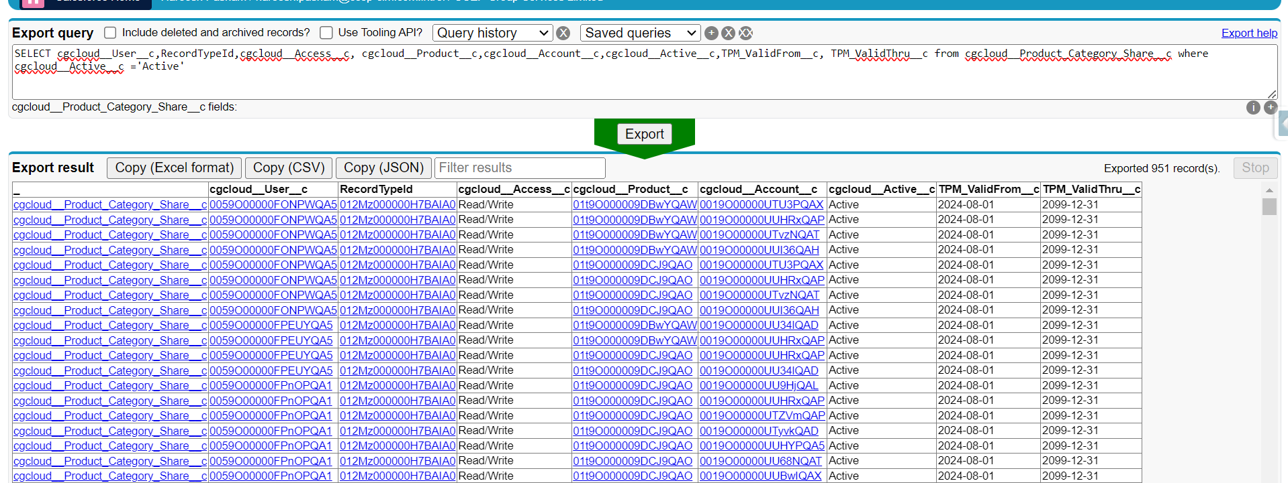

Step 2: Click on “Copy (Excel format)” and past it in Excel sheet.

Step 3: Follow below steps to add data in the Excel sheet,

cgcloud__User__c : Copy the Id of the User from Users and Paste it in the Excel sheet.
RecordTypeId : Copy the Id from Exported data and Paste it in the Excel sheet.
cgcloud__Access__c: value is Read/Write
cgcloud__Product__c: Copy the Id’s of Immediate Consumption and Future Consumption from Exported data and Past it in the Excel sheet.
cgcloud__Account__c: Copy the Id’s of Accounts (for eg; Amazon, EDEKA, LIDL) from Exported data and Past it in the Excel sheet.
cgcloud__Active__c: value is Active
TPM_ValidFrom__c: value is 2024-08-01
TPM_ValidThru__c: value is 2099-12-31
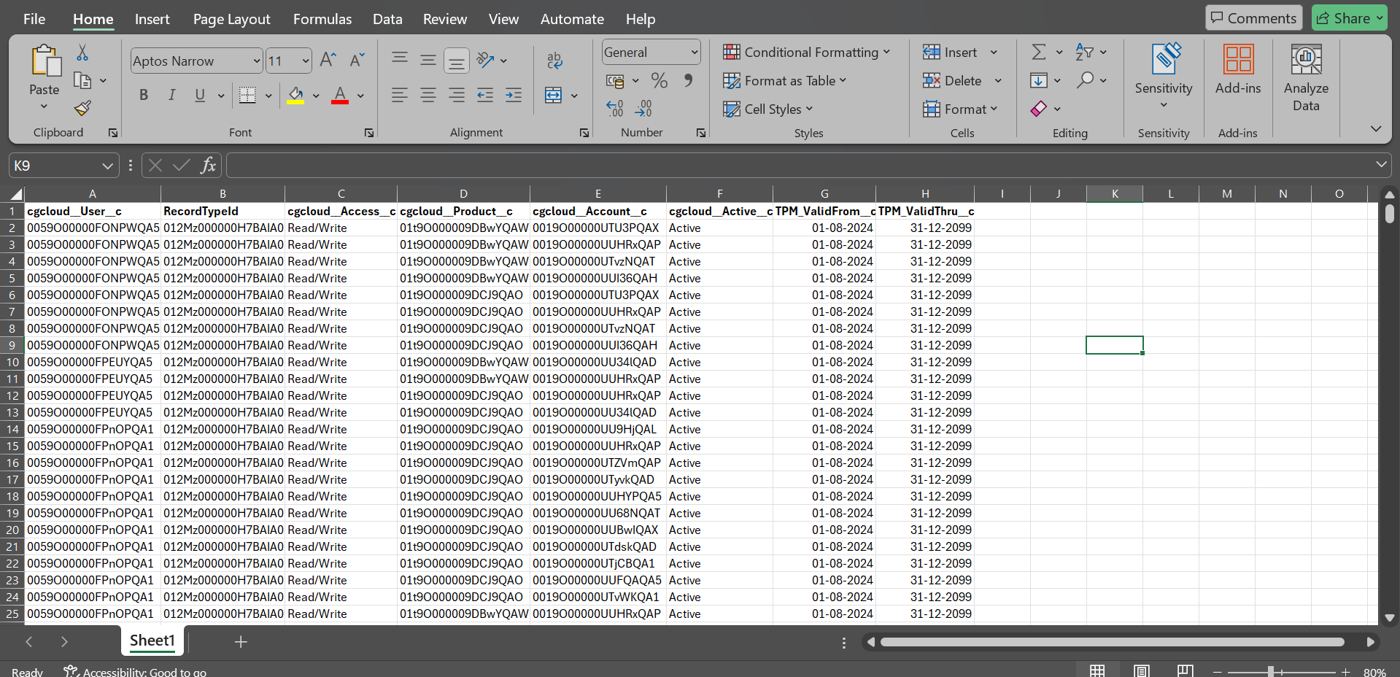
Step 4: Open Data import and give the below field values,

Action: Insert
Object: cgcloud__Product_Category_Share__c
Data: Copy the data added in the Excel sheet following Step 3 and paste it in the Data Field

Step 5: Click on the Import button below to Insert the data.
